**DISTANCE, DISPLACEMENT, SPEED, AND VELOCITY EXAM REVIEW**

**www.physicsclasssroom.com**

**Basic Information:** Complete the following:

* **The slope on a Position vs. Time graph indicates _______________.**
* **A ______________ is a quantity that requires magnitude only to fully describe it.**
* **A vector is a quantity that requires both _____________ and _____________ to fully describe it.**

**Equations:** Complete the table, writing the equation for each quantity in the appropriate space, and ***label the variables*:**

|  |  |  |
| --- | --- | --- |
| **Displacement** | **Average Speed** | **Average Velocity** |
|  |  |  |

1. Which of the following statements about vectors and scalars are TRUE? Write T next to the TRUE statements.

_____A vector is a large quantity and a scalar is a small quantity.

_____A scalar quantity has a magnitude and a vector quantity does not.

_____A vector quantity is described with a direction and a scalar is not.

_____The quantity 20 m/s, north is a speed and as such is a scalar quantity.

2. Which of the following statements about distance and/or displacement are TRUE? Write T next to the TRUE statements.

_____Distance is a vector quantity and displacement is a scalar quantity.

_____A person makes a round-trip journey, finishing where she started. The displacement for the trip is 0,

_____A person makes a round-trip journey, finishing where she started. The distance traveled for the trip is 0,

_____A person starts at position A and finishes at position B. The distance traveled is the length of the segment from A to B.

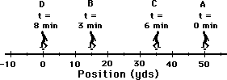_____If a person walks in a straight line *and never changes direction*, then the distance and the displacement will have exactly the same magnitude.

_____The phrase "20 mi, northwest" likely describes a distance traveled.

_____The phrase "20 m, west" likely describes a displacement traveled.

_____The diagram to the right depicts the path of a person walking to and fro from position A to B to C to D. The distance for this motion is 100 yds.

**SHOW YOUR WORK:**

_____For the same diagram below, the displacement is 50 yds.

**SHOW YOUR WORK:**

3. Which of the following statements about velocity and/or speed are TRUE?

_____Velocity is a vector quantity and speed is a scalar quantity.

_____Both speed and velocity refer to how fast an object is moving.

_____Person X moves from location A to location B in 5 seconds. Person Y moves between the same two locations in 10 seconds. Person Y is moving with twice the speed as person X.

_____The velocity of an object refers to the rate at which the object's position changes.

_____It is possible that an object could move very fast yet have a very small velocity.

_____The phrase "30 mi/hr, west" likely refers to a scalar quantity.

_____The average velocity of an object on a round-trip journey would be 0.

_____The direction of the velocity vector is dependent upon two factors: the direction the object is moving and whether the object is speeding up or slowing down.

_____The diagram above depicts the path of a person walking to and fro from position A to B to C to D. The entire motion takes 8 minutes. The average speed for this motion is approximately 11.3 yds/min

**SHOW YOUR WORK:**

_____For the same diagram above, the average velocity for this motion is 0 yds/min

**SHOW YOUR WORK:**

4. Which of the following statements about position-time graphs are TRUE? List all that apply.

_____Position-time graphs cannot be used to represent the motion of objects with accelerated motion.

_____The slope on a position-time graph is representative of the acceleration of the object.

_____A straight, diagonal line on a position-time graph is representative of an object with a constant velocity.

_____If an object is at rest, then the position-time graph will be a horizontal line.

_____Accelerating objects are represented on position-time graphs by curved lines.

_____An object with a positive velocity will be represented on a position-time graph by a line with a positive slope.

_____An object with a negative velocity will be represented on a position-time graph by a line with a negative slope.

_____An object with a positive acceleration will be represented on a position-time graph by a line which curves upwards.

_____An object with a negative acceleration will be represented on a position-time graph by a line which curves downwards.

**Multiple Choice** **Practice:** Circle the BEST answer.

 

5. If an object is moving eastward and slowing down, then the direction of its velocity vector is ____.

|  |  |  |  |
| --- | --- | --- | --- |
| a. eastward | b. westward | c. neither | d. not enough info to tell |

6. Which one of the following quantities is NOT a vector?

|  |  |  |  |
| --- | --- | --- | --- |
| a. 10 mi/hr, east | b. 10 mi/hr/sec, west | c. 35 m/s, north | d. 20 m/s |

7. Which one of the following quantities is NOT a speed?

|  |  |  |  |
| --- | --- | --- | --- |
| a. 10 mi/hr | b. 10 mi/hr/sec | c. 35 m/s | d. 20 m/s |

8. The average speed of an object which moves 10 kilometers (km) in 30 minutes is ____.

|  |  |  |  |
| --- | --- | --- | --- |
| a. 10 km/hr | b. 20 km/hr | c. 30 km/hr | d. more than 30 km/hr |

9. What is the acceleration of a car that maintains a constant velocity of 55 mi/hr for 10.0 seconds?

|  |  |  |  |
| --- | --- | --- | --- |
| a. 0 | b. 5.5 mi /hr/s | c. 5.5 mi /s/s | d. 550 mi/hr/s |

http://www.physicsclassroom.com/reviews/1Dkin/q28.gif10. Renatta Oyle is again found driving her '86 Yugo down Lake Avenue, leaving the following trail of oil drops on the pavement. If her car is moving from right to left, then ...

1. her velocity has a rightward direction and her acceleration has a rightward direction.
2. her velocity has a rightward direction and her acceleration has a leftward direction.
3. her velocity has a leftward direction and her acceleration has a rightward direction.
4. her velocity has a leftward direction and her acceleration has a leftward direction.

**Position vs Time Graphs:** On the position-time axes below, sketch a plot representing the motion described above each:

|  |  |  |  |  |  |  |
| --- | --- | --- | --- | --- | --- | --- |
| **At Rest** | **Moving in the Positive Direction with Constant Speed** | **Moving in the Negative Direction and Speeding Up** | **Moving in the Positive Direction and Speeding Up** | **Moving in the Negative Direction with Constant Speed** | **Moving in the Positive Direction and Slowing Down** | **Moving in the Negative Direction and Slowing Down** |
| http://www.physicsclassroom.com/reviews/1Dkin/q31.gif | http://www.physicsclassroom.com/reviews/1Dkin/q31.gif | http://www.physicsclassroom.com/reviews/1Dkin/q31.gif | http://www.physicsclassroom.com/reviews/1Dkin/q31.gif | http://www.physicsclassroom.com/reviews/1Dkin/q31.gif | http://www.physicsclassroom.com/reviews/1Dkin/q31.gif | http://www.physicsclassroom.com/reviews/1Dkin/q31.gif |

**Use the G.U.E.S.S. Method to solve the following exercises:**

1. A dolphin can swim 1.85 km/hr. How far does a dolphin travel after 0.60 hr?
2. A cheetah can maintain its maximum speed of 27.8 m/s for only 30 seconds. (a) What distance would a cheetah travel at this top speed in this time? (b) How much time would it take a gazelle, traveling at 22.2 m/s, to cover this same distance?

**Use the Position vs. Time Graph Shown to the Right to Answer the Following Questions:**

1. 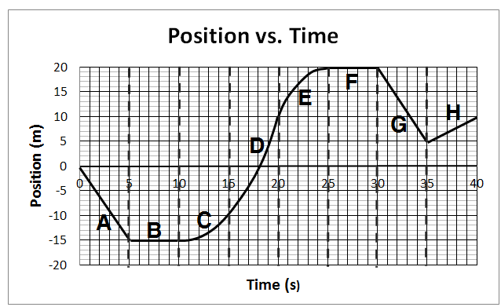Which time interval(s) on the graph (A, B, C, etc) represent constant positive velocity?
2. Which time interval(s) on the graph represent constant negative velocity?
3. Which time interval(s) show moving forward, in the positive direction?
4. Which time interval(s) show slowing down?
5. During which time interval is the object NOT moving?
6. Which time interval(s) show speeding up?
7. What is the total distance traveled during the 40 seconds shown?

(SHOW YOUR WORK)

1. What is the total displacement that occured during the 40 seconds shown?

(SHOW YOUR WORK)

1. What is the average speed of the object from t = 10 to 20 seconds?

(SHOW YOUR WORK)

1. What is the average velocity of the object from t = 20 to 35 seconds?

(SHOW YOUR WORK)