Velocity vs. Time Graphs: We can, and often do, plot the velocity of an object as it varies with time. We call this a Velocity vs. Time graph. Below is an example of such a graph. Describe the motion represented by the graph:
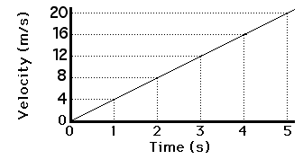

The graph below shows the velocity for a remote control car as a function of time. For each of the time intervals A - G, indicate the type of motion shown: Each response should include “speeding up”, “slowing down”, “constant velocity”, or “at rest” AND “moving forward”, “moving backward”, or “not moving”

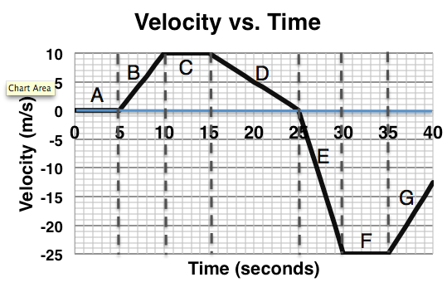
A:

B:

C:

D:

E:

F:

G:

Explain what evidence you used to determine whether or not the car was speeding up, slowing down, or moving with constant speed. Be Specific:

Explain what evidence you used to determine whether or not the car was moving forward or backward. Be Specific:

BIG IDEA: The SLOPE of the Velocity vs. Time graph is ______________________________.

Average Acceleration: $\overline{a}=\frac{Δv}{Δt}=\frac{v_{f}-v_{i}}{t_{f}-t_{i}}$

This means, whatever you can say about the slope, you can say about the acceleration – if the slope is constant, the acceleration is constant. If the slope is positive, the acceleration is positive. If the slope is zero, the acceleration is zero.

Use the graph below to answer the following questions:

During which time intervals (A – G) of the graph do you see positive accelerations? Can an object that has positive acceleration be slowing down?

During which do you see negative accelerations? Can an object that has negative acceleration be speeding up?

During which time intervals do you see zero acceleration? Can an object with zero acceleration be moving?

What is the average acceleration from t = 0 to 40 seconds? SHOW YOUR WORK

What is the average acceleration from t = 15 to 25 seconds? SHOW YOUR WORK

